- Introduction to Addressing Theory

Q.1 List the key differences between IPv4 and IPv6 addressing by creating a two-column table with at least 4 points for each?

Answer

IPv4 | IPv6
- Uses 32-bit addresses | Uses 128-bit addresses
- Example: 192.168.1.10 | Example: 2001:db8::10
- Supports about 4.3 billion addresses | Supports a very large number of addresses
- Written in decimal numbers separated by dots | Written in hexadecimal numbers separated by colons
- Commonly uses NAT because of limited addresses | Usually does not require NAT because of the large address space
- Example private range: 192.168.x.x | Example unique local range: fd00::/8

Q.2 Given the following scenario: You have 4 devices (laptop, phone, smart TV, and printer) connected to your home WiFi. Assign a unique static IPv4 address to each device using the 192.168.10.0/24 network, and write down the IP, subnet mask, and default gateway for each device?

Answer

- Static IPv4 Addresses for Home Devices
Given Network: 192.168.10.0/24
Subnet Mask: 255.255.255.0
Default Gateway: 192.168.10.1

Device | Static IP Address | Subnet Mask | Default gateway
1. Laptop | 192.168.10.10 | 255.255.255.0 | 192.168.10.1
- Phone | 192.168.10.20 | 255.255.255.0 | 192.168.10.1
- Smart TV | 192.168.10.30 | 255.255.255.0 | 192.168.10.1
- Printer | 192.168.10.40 | 255.255.255.0 | 192.168.10.1

- Each device has a unique IP address, while all devices use the same subnet mask and default gateway.

Q.3 Calculate the number of valid subnets and hosts per subnet if you use a /27 CIDR subnet mask on a 192.168.1.0 network. List the first three valid subnet address ranges (network address to broadcast address) and the usable host IPs in each?

Answer
- Subnetting 192.168.1.0 Using /27
Given Network: 192.168.1.0
CIDR Mask: /27
Subnet Mask: 255.255.255.224
- Step 1: Number of Subnets
A /24 network is being divided into /27 subnets.
Bits borrowed:
27 - 24 = 3 bits
Number of subnets:
2³ = 8 subnets
- Step 2: Hosts Per Subnet
Host bits:
32 - 27 = 5 bits
Total addresses per subnet:
2⁵ = 32
Usable hosts:
32 - 2 = 30 hosts
- Therefore:
Number of Subnets = 8
Usable Hosts per Subnet = 30
First Three Subnets
Subnet | Network Address | Usable Host Range | Broadcast Address
1 | 192.168.1.0 | 192.168.1.1 – 192.168.1.30 | 192.168.1.31
2 | 192.168.1.32 | 192.168.1.33 – 192.168.1.62 | 192.168.1.63
3 | 192.168.1.64 | 192.168.1.65 – 192.168.1.94 | 192.168.1.95

Q.4 You are given the IP address 10.0.5.17 with subnet mask 255.255.255.0. Determine the network address, broadcast address, and the range of valid host addresses for this subnet.<br><br><em><strong>Hint:</strong> Convert the subnet mask to CIDR notation and use bitwise AND for network address calculation.</em>?

Answer

- IP Address Calculation
Given:
IP Address: 10.0.5.17
Subnet Mask: 255.255.255.0
- Step 1: Convert Subnet Mask to CIDR
255.255.255.0 = /24
- Step 2: Network Address
Using the IP address and subnet mask:
10.0.5.17 AND 255.255.255.0
Network Address:
10.0.5.0
- Step 3: Broadcast Address
The last address in the /24 network is:
10.0.5.255
- Step 4: Valid Host Range
First usable IP:10.0.5.1
Last usable IP:10.0.5.254
- Final Answer
Network Address: 10.0.5.0
Broadcast Address: 10.0.5.255
Valid Host Range: 10.0.5.1 – 10.0.5.254
Subnet Mask: 255.255.255.0
CIDR: /24

Q.5 Use an online subnet calculator tool (such as https://www.subnet-calculator.com/) to verify your answer for the previous task. Take a screenshot of your calculation and write one line explaining if your manual answer matched the tool's output?

Answer

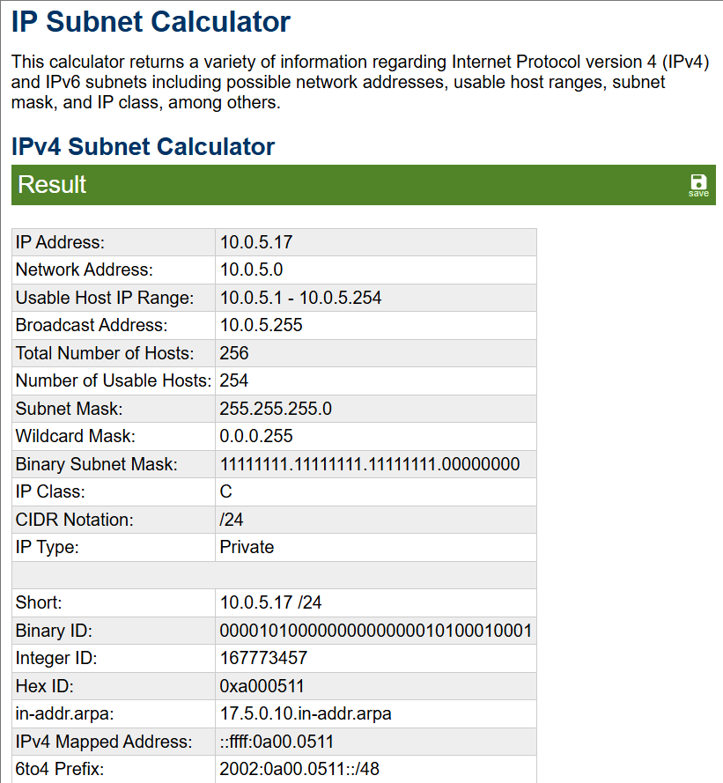

- My manual calculation matched the online subnet calculator output. Both showed the network address as 10.0.5.0, broadcast address as 10.0.5.255, and usable host range as 10.0.5.1 to 10.0.5.254.output.

